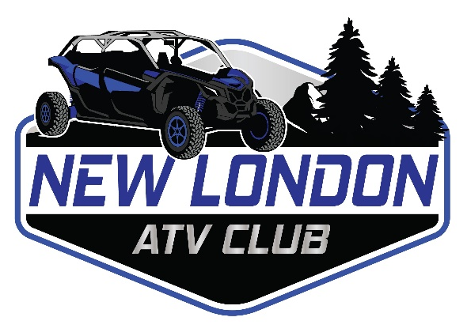
Hello Future Sponsor,
The New London ATV Club is a non-profit, locally organized ATV club that promotes a family atmosphere, safe riding, training, and cherishes local community involvement opportunities. Our club provided many guided rides throughout Waupaca and Shawano Counties. These rides introduce new riders to the ATV/UTV sport. These rides show new riders as well as experienced riders how to ride respectfully and safely. These rides provide a group atmosphere where people of all experience levels can ride ATVs and UTVs together. It creates friendships and bonds that can last a lifetime.
The New London ATV Club was a great community and sponsorship asset throughout 2021 and we are looking forward to having a positive community impact in 2022.
Some of our 2021 club highlights were:
- Raising funds for Susan G Komen Cancer Research.
- Raising funds for the Salvation Army through seasonal bell ringing in New London.
- Hosting local ride events.
- Recognition for Community Service Award by the New London Chamber of Commerce.
- Growing the WI Trail Ambassador locally to educate, support, assist and advocate for ATV / UTV activities.
The New London ATV Club is currently seeking sponsorships for the 2022 calendar year. Valuable sponsor proceeds help support the club with future events and goals including:
- Annual New London ATV Poker Run scheduled for September 24, 2022.
  - Our 2021 Poker Run was a great success. If you would like to be part of event, we would welcome your support. It would give opportunity for participants to patronize your business.
- Ride New London ATV / UTV route maps that include promotional material for our sponsors.
- ATV & UTV Safety Training.
- Purchase of 2 Way Radios for events and rides
- Basic First Aid, AED, CPR & lifesaving training for our members.
  - In 2021 the club trained 10 members, acquired an AED & distributed valuable first aid supplies.
- Continued support of Adopt-A-Family via the Salvation Army.
  - Last year we helped make Christmas brighter for 2 local families in need.
- New London ATV club will be hosting the Wisconsin ATV Association (WATVA) regional meeting for ATV clubs from across the state of Wisconsin.
How your sponsorship directly benefits your business or organization:
- Your business is listed on New London ATV Route maps that are posted & available at several locations in the New London area.
  - Gold Sponsors receive a double size logo location on perimeter of the ride map.
  - Silver Sponsors receive a single logo location on the perimeter of the ride map.
  - Bronze Sponsors are included on the map via a single typeset line.
- Your business is listed on our Facebook and the newlondonatvclub.com website.
  - We include your business or organization name, address, contact information and a direct link to your website.
  - New this year- Gold Sponsors in 2022 will have their logo included on the New London ATV website.
- Gold sponsors will have their logo included on a large club banner that is proudly displayed at local events.
- Gold sponsors can actively advertise on the New London ATV Facebook page.
- We support, actively patronize and advocate for our sponsors.
We look forward to our partnership as a New London ATV Club sponsor. Should you have any questions, feel free to contact us via email at newlondonatvclub@gmail.com, by phone at (920) 538-1975 or on our website at newlondonatvclub.com. Please mail all sponsorship applications to New London ATV Club, c/o Don Schend, 314 West Rowland, New London WI 54961.

Thank you.
The New London ATV Club

Board of Directors:
President- Don Schend
Vice President- Pete Genteman
Secretary- Vanessa Genteman
Treasurer- Tonya Scheid
Paul Herminath
Shawn Retzlaff
Cora Handschke

