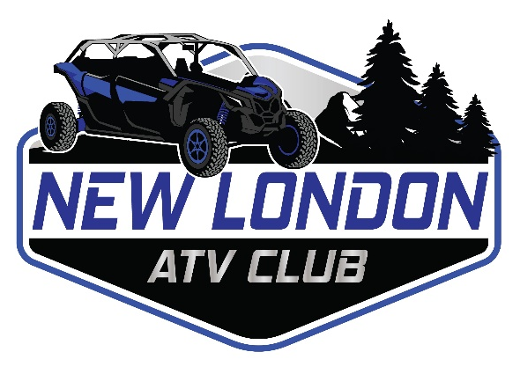
Business Name:_ _____________________________________________________________
Address:_____________________________________________________________________
Phone:_____________________________ Email:___________________________________
Website:_____________________________________________________________________
Facebook:____________________________________________________________________
Sponsorship Levels

Bronze $75-$150
One line on the New London ATV Route Map
Link to Facebook and/or website on NewLondonATVClub.com website

Silver $151-$250
One Logo Spot on the New London ATV Route Map
Link to Facebook and/or website on NewLondonATVClub.com website

Gold $251+
Double Logo Spot on the New London ATV Route Map
Link to Facebook and/or website on NewLondonATVClub.com
Business Logo included on the NewLondonATVClub.com website
Full ability to share information and advertising to the New London ATV Club Facebook Group
Logo on banner that will be at all New London ATV Club events(Must be submitted by 5/15)

Pay by cash or check make payable to the New London ATV Club

